|  |
| --- |
| Voting System Software |
| C Programming Mini Project |
| It’s a complete c programming project on election system. With this software any election commission can organize a peaceful and doubtless election. Normally this software have made on basis of different community election like Class Representative Election, Team leader election, It can be used in any kind of small and large organization to elect their leader. Firstly it is 100% secure for public election but can be used by ensuring most security. |



8/24/2015



**Department of Computer Science & Engineering**

**B.Sc(Engg.) by Project (2014-2015)**

**Proposed Project Title:**

*Voting system software.*

**Submitted By:**

*Ripon Chandra das*

*Roll: 13CSE046*

*Id No: 520*

*Department of Computer Science & Engineering*

**Supervised By:**

*Md. Mahbub E Noor*

*Lecturer,*

*Department of Computer Science & Engineering*

**Date of Submission:** 24 August,2015

**Web :** [www.barisaluniv.edu.bd](http://www.barisaluniv.edu.bd)

***Acknowledgement***

*First of all I would like to thank the Almighty God. Today I have successfully completed my work with such ease because he gave me the ability, chance and a cooperating supervisor. I would like to take the opportunity to express my gratitude to Md. Mahbub E Noor ,my respected supervisor. Despite of being burdened with several other activities, he gave me a fair share of his time in this work. He not only gave us time but also proper guidance and valuable advice whenever I faced difficulties, or lacked confidence. His comments and guidance helped us a lot in preparing my project report. I am also thankful to our friends who helped me in a number of ways by providing various resources and moral support. Last of all I am grateful to my family; who are always with me in my every step of this project.*

**Declaration:**

I, thereby, declare that the work presented in this Project is the outcome of the investigation performed by me under the supervision of Md. Mahbub E Noor, Lecturer, Department of Computer Science and Engineering, University of Barisal, Barisal, Bangladesh. I also declare that no part of this Project and there of has been or is being submitted elsewhere in our university or anywhere in the world as I know.

Countersigned Signature

Md Mahbub E Noor Ripon Chandra das

Supervisor Candidate

***TABLE OF CONTENTS***

**Abstract Page**

**Chapter 1: Introduction 1**

1.1 Introduction to the problem issues

1.2 Prospect of the issues

**Chapter 2:** **Background Study of Project** 2

**Chapter 3: System analysis 3**

3.1 Software Requirement Specification

**Chapter 4: System Design 4-9**

4.1 Input

4.2 Output

4.3 Algorithm

**Chapter 5: Coding and Implementation 10-26**

**Chapter 6: Output and Result Discussion 27-47**

**Chapter 7: Conclusion and Reference 48**

**Abstract:**

It’s a complete c programming project on election system. With this software any election commission can organize a peaceful and doubtless election. Normally this software have made on basis of different community election like Class Representative Election, Team leader election, It can be used in any kind of small and large organization to elect their leader. Firstly it is 100% secure for public election but can be used by ensuring most security.

**Chapter 1:**

**Introduction**

A voting system software is used to supervised a community election. There have several candidate and some voter have to joined in a community election. First election commission set up all the information of the election and open user window. General user only can use the user window and can apply their voting right. Only the election commission reserved all the right to access to all the features of the program.

* 1. **Introduction to the problem issues :**

This project have made with a simple coding using the language C. Some common feature and built-in-function are used to complete the program. As concepts first election commission set out all the information, for this purpose structure have used. Use of some user-defined function make the modular and easy to understand.

* 1. **Prospect of the issues :**

The aim of this project is to organize an election without any conflict and doubt. It’s a software that can organize an election in about 1000 voter attendance. It will be helpful for a nation to established democratic system in all the sector of the country with an easy voting system software.

**Chapter 2: Page-2**

**Background Study of Project**

For doing a project I have needed to study about c language, Structure, time, string, C functions to generate menus, show message boxes and print text on the screen. It also effectively applies the various C

**Chapter 3: Page-3**

**System Analysis**

**Software Requirement Specification**

**Operating System :** Windows 7/XP/8/8.1/10

**Compiler :** GNU GCC

**IDE:** Code-blocks 12:13

**Microprocessor :** Minimum1GHz

**RAM:**Minimum1GB

**Hardware:** A personal Computer

**Chapter 4: Page-4**

**System Design**

**4.1 Inputs**

1. Name of election

2. Number of Candidate and Number of Voter

3. Symbol or Name of each Candidate

**4.2 Output**

1.Vote for Candidate (1…….n) is n.

**4.3 Algorithm:**

Step-1: Start;

Step-2: Enter Password;

Step-3: If password match show main menu else repeat step-2;

Step-4: Read the value of n;

Step-5: If n=1 go to step-6, If n= 2 go to step-7, If n=3 go to step-9, If n=4 go to step-10, If n=5 go to step-6, If n=6 go to step-11, If n=7 go to step-12, If n=8 go to step-13, If n=0 go to step-14;

Step-6: Enter the name of the election, Candidate number, Voter number and candidate name or symbol and read the value of c, if c=1 go to step-7 else if c=2 go to step-3;

Step-7: Read voter ID and Read the value of m;

Step-8: Repeat step-7 equal number of voter and then go to step-3;

Step-9: open file “Record.txt” and view result of the election;

Step-10: Read a character. If character =y or Y remove the file “Record.txt”. If character=n or N cancel erasing the file.

Step-11: Open file file.HLP file and show details and repeat step-3;

Step-12: Open “input_file.txt” file and show inputted information and repeat step-3;

Step-13: Close application;

Step-14: Stop.

**Chapter 5: Page-10**

**Coding and Implementation**

**Source Code of the program:**

#include<stdio.h> //Including printf(),scanf()

#include<windows.h> //including Sleep()

#include<string.h> //Including strcmp etc

#define MAX 20

void Password(void);

void input(void);

int user(void);

void viewdata(void);

void result(int n);

void mainmenu(void);

int t(void);

void view(void);

void del(void);

void close(void);

void help(void);

struct candidate

{

char name[15];

int vote;

}

can[MAX];

FILE *f1;

FILE *fp;

int can_num;

int id_range;

int i,j;

char ename[20];

int main(void)

{

system("color 5a");

Password();

return 0;

}

void Password(void)

{

system("cls");

printf(" \xDB\xDB\xDB ELECTRONIC VOTING MACHINE \xDB\xDB\xDB\n\n");

char d[25]="Password Protected";

char ch,pass[10];

char c,password[10]="csebu";

int i=0,j;

for(j=0;j<20;j++)

{

printf("*");

Sleep(50);

}

for(j=0;j<20;j++)

{

Sleep(50);

printf("%c",d[j]);

}

for(j=0;j<20;j++)

{

Sleep(50);

printf("*");

}

printf("\nEnter Password:");

while(ch!=13)

{

ch=getch();

if(ch!=13 && ch!=8){

putch('*');

pass[i] = ch;

i++;

}

}

pass[i] = '\0';

if(strcmp(password,pass)==0)

{

system("cls");

printf("\n\nLOADING.....\n");

for(j=0;j<60;j++)

{

Sleep(10);

printf("\xB2");

}

system("cls");

printf("\nPassword match");

printf("\nPress any key to continue......");

getch();

mainmenu();

}

else

{

printf("\n\n\aWarning!! Incorrect Password");

getch();

Password();

}

}

void mainmenu(void)

{

system("cls");

int n;

char c;

///printf("\nPress any key to continue...");

///getch();

printf("\n\n\xB2\xB2\xB2\xB2\xB2\xB2\xB2\xB2\xB2\xB2\xB2\xB2\xB2\xB2 MAIN MENU");

printf(" \xB2\xB2\xB2\xB2\xB2\xB2\xB2\xB2\xB2\xB2\xB2\xB2\xB2\xB2");

printf("\n\xDB\xDB\xDB\xDB\xDB\xDB\xDB\xB2 1. Input data");

printf("\n\xDB\xDB\xDB\xDB\xDB\xDB\xDB\xB2 2. User Window");

printf("\n\xDB\xDB\xDB\xDB\xDB\xDB\xDB\xB2 3. View result");

printf("\n\xDB\xDB\xDB\xDB\xDB\xDB\xDB\xB2 4. Delete data");

printf("\n\xDB\xDB\xDB\xDB\xDB\xDB\xDB\xB2 5. Edit Candidate's Record");

printf("\n\xDB\xDB\xDB\xDB\xDB\xDB\xDB\xB2 6. HELP");

printf("\n\xDB\xDB\xDB\xDB\xDB\xDB\xDB\xB2 7. View Election Info");

printf("\n\xDB\xDB\xDB\xDB\xDB\xDB\xDB\xB2 8. Close Application");

printf("\n\xDB\xDB\xDB\xDB\xDB\xDB\xDB\xB2 0. Quick Exit");

printf("\n------------------------------------------\n");

t();

printf("Enter your choice:");

scanf("%d",&n);

c=getchar();

if(isalpha(c))

{

printf("\n\nYou have pressed a alphabet\nPress any key to continue... \n");

getch();

mainmenu();

}

while(n!=0)

{

switch(n)

{

case 1:

input(); //Inputing info

break;

case 2:

for(j=1;j<=id_range;j++){

user();

}

system("cls");

printf("\nEnter 1 for Main Menu:");

scanf("%d",&c);

if(c==1)

Password();

else

user();

break;

case 3:

view(); //Reading info from file

break;

case 4:

del(); //Delete the data file

break;

case 5:

input();

break;

case 6:

help();

break;

case 7:

viewdata();

break;

case 8:

close();

break;

default:

printf("\n You have pressed wrong number. Please press ");

break;

}

system("cls");

printf("\n\nEnter 1 for Main Menu:");

printf("\nEnter any key to Exit:");

}

}

void input(void)

{

int c;

system("cls");

printf("\nBefore using please visit HELP option.\n");

printf("\nEnter 1 for HELP Option or press any to continue.....");

if(getchar()=='1')

help();

else

getch();

system("cls");

fp=fopen("input_file.txt","a");

fprintf(fp,"............Election Record.............\n");

printf("\n\n\xB2\xB2\xB2\xB2\xB2\xB2\xB2\xB2\xB2\xB2\xB2\xB2\xB2 WELCOME ELECTION COMMISSION WINDOW");

printf(" \xB2\xB2\xB2\xB2\xB2\xB2\xB2\xB2\xB2\xB2\xB2\xB2\xB2");

printf("\nEnter the name of the election:");

gets(ename);

//gets(ename);

fprintf(fp,"Name of the election: %s\n",ename);

printf("\nNumber of Candidate:");

scanf("%d",&can_num);

fprintf(fp,"Number of Candidate: %d\t",can_num);

printf("Number of Voter:");

scanf("%d",&id_range);

fprintf(fp,"Number of Voter: %d\n",id_range);

printf("\nPress any key to continue...");

getch();

system("cls");

printf("..........Welcome to %s",ename);

printf("\n\nPlease input %d name or symbol of the candidate:\n",can_num);

for(i=1;i<=can_num;i++){

printf("\nName %d:",i);

gets(can[i].name);

gets(can[i].name);

}

fprintf(fp,"Candidate name or symbol:\n");

for(i=1;i<=can_num;i++){

fprintf(fp,"%d. %s\n",i,can[i].name);

}

printf("\nPress any key to Continue....");

getch();

system("cls");

printf("\n\nEnter 1 for user's Window:\n");

printf("Enter 2 for main menu:");

scanf("%d",&c);

if(c==2)

{

mainmenu();

}

else if(c==1)

{

for(j=1;j<=id_range;j++){

user();

}

system("cls");

printf("\nEnter 1 for Main Menu:");

scanf("%d",&c);

if(c==1)

Password();

else

user();

}

}

int user(void)

{

system("cls");

int id,m;

char c;

static check;

printf("\xDB\xDB\xDB\xDB\xDB\xDB\xDB\xB2\xDB\xDB\xDB\xDB\xDB\xDB\xDB\xB2\xDB\xDB\xDB\xDB\xDB\xDB\xDB\xB2\xDB\xDB\xDB\xDB\xDB\xDB\xDB\xB2\xDB\xDB\xDB\xDB\xDB\xDB\xDB\xB2\n");

printf("Welcome to %s",ename);

printf("\n\xDB\xDB\xDB\xDB\xDB\xDB\xDB\xB2\xDB\xDB\xDB\xDB\xDB\xDB\xDB\xB2\xDB\xDB\xDB\xDB\xDB\xDB\xDB\xB2\xDB\xDB\xDB\xDB\xDB\xDB\xDB\xB2\xDB\xDB\xDB\xDB\xDB\xDB\xDB\xB2\n");

t();

printf("Voter: 0%d\n\n",j);

printf("Input ID:\n");

scanf("%d",&id);

if(id>0 && id<=id_range)

{

if(id==check){

printf("Blocked");

getch();

user();

}

else{

printf("\nApply your voting right....");

for(i=1;i<=can_num;i++){

printf("\nEnter %d for %s",i,can[i].name);

}

scanf("%d",&m);

c=getchar();

if(isalpha(c))

{

printf("\n\nYou have pressed a alphabet\nPlease chose your option again.... \n");

return;

}

}

check=id;

}

result(m);

}

void result(int n)

{

FILE *f1;

time_t t;

for(i=1;i<=can_num;i++)

{

if(n==i){

can[i].vote=can[i].vote+1;

}

}

f1=fopen("Record.txt","a");

fprintf(f1,"\n\n");

fprintf(f1,"\t\tLast Update of %s is:\n",ename);

time(&t);

fprintf(f1,"\tTime:%s\n",ctime(&t));

for(i=1;i<=can_num;i++)

{

fprintf(f1,"\tVote of %s is: %d",can[i].name,can[i].vote);

}

fclose(f1);

}

void view(void)

{

int m;

char c;

system("cls");

f1=fopen("Record.txt","r");

if((c=getc(f1))==EOF)

{

printf("\n\nNo data found.Please enter a record first\n\n");

getch();

}

while((c=getc(f1))!=EOF)

printf("%c",c);

fclose(f1);

printf("\n\nEnter any key to continue....");

getch();

system("cls");

printf("\nEnter 1 for main menu:");

printf("\nEnter any Number to Exit:");

scanf("%d",&m);

if(m==1)

mainmenu();

else

close();

}

void del(void)

{

system("cls");

int m;

char opt;

printf("Welcome to %s \n\n",ename);

printf("\n\aDo You want to erase the file?...(Y/N)?");

scanf(" %c",&opt);

if(toupper(opt)=='Y')

{

if(remove("Record.txt"))

{

printf("\nCan not erase file.\n ");

return 0;

}

printf("\nErase file successfully.\n");

}

else

printf("\n\nErasing canceled\n\n");

printf("press any to continue........");

getch();

system("cls");

printf("\nEnter 1 for main menu:");

printf("\nEnter any Number to Exit:");

scanf("%d",&m);

if(m==1)

mainmenu();

else

close();

}

int t(void)

{

time_t t;

time(&t);

printf("Time & Date is:%s",ctime(&t));

}

void help(void)

{

system("cls");

system("color f0");

int m;

FILE *f1;

char ch;

f1=fopen("file.HLP","r");

while((ch=getc(f1))!=EOF)

printf("%c",ch);

fclose(f1);

printf("\n\nPress any to continue........");

getch();

system("cls");

printf("\nEnter 1 for main menu:");

printf("\nEnter any Number to Exit:");

scanf("%d",&m);

if(m==1)

mainmenu();

else

close();

}

void close(void)

{

printf("\a\nWaiting....");

Sleep(1000);

exit(0);

}

void viewdata(void)

{

int m;

char c;

system("cls");

fp=fopen("input_file.txt","r");

if((c=getc(fp))==EOF)

{

printf("\n\nNo data found.Please enter a record first\n\n");

getch();

}

while((c=getc(fp))!=EOF)

printf("%c",c);

fclose(fp);

printf("\n\nEnter any key to continue....");

getch();

system("cls");

printf("\nEnter 1 for main menu:");

printf("\nEnter any Number to Exit:");

scanf("%d",&m);

if(m==1)

mainmenu();

else

close();

}

**Chapter 6:**

**Output and Result Discussion**

First Window of the proram:

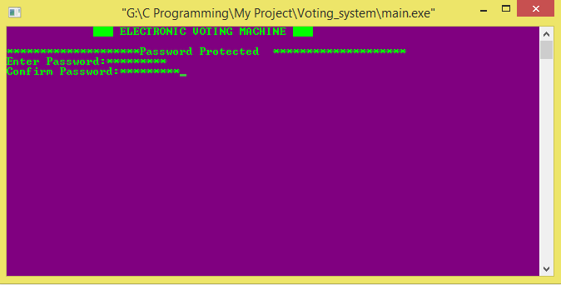

After inputting password:

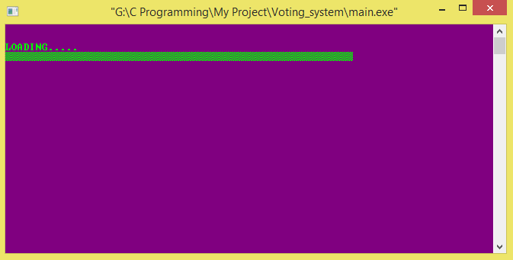

Main menu of the program:

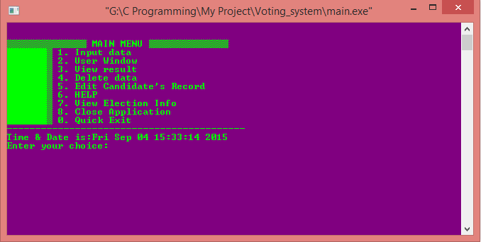

After entering 1:

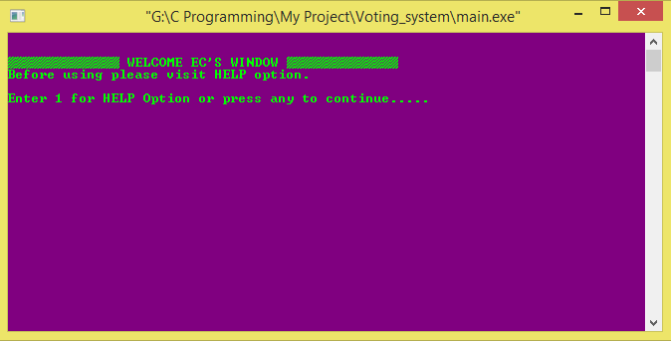

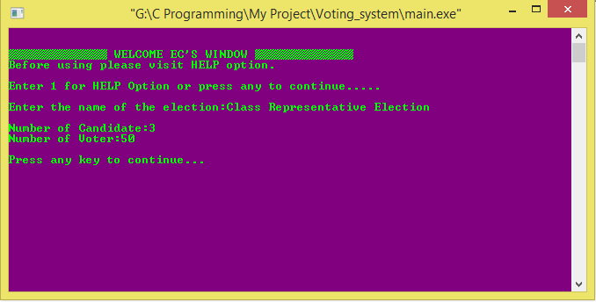

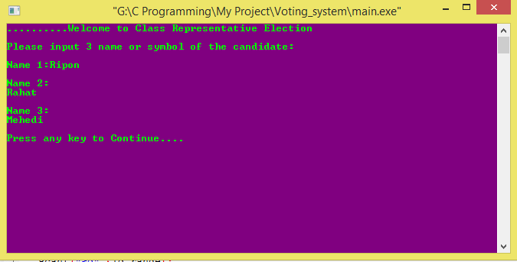

User Window:

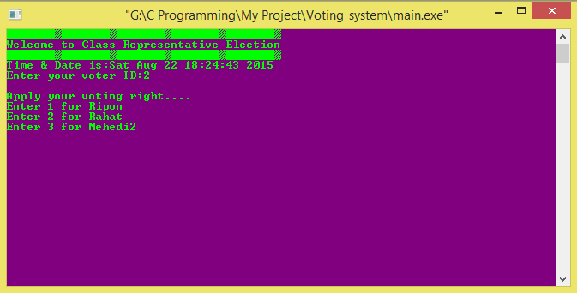

View Inputted data:

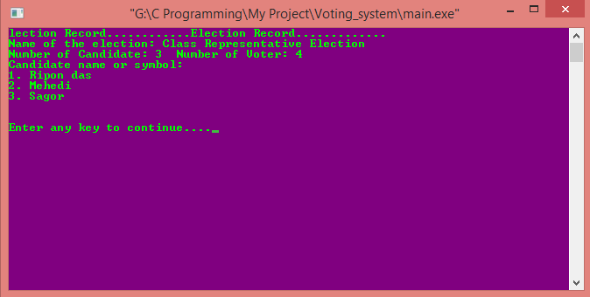

View Result:

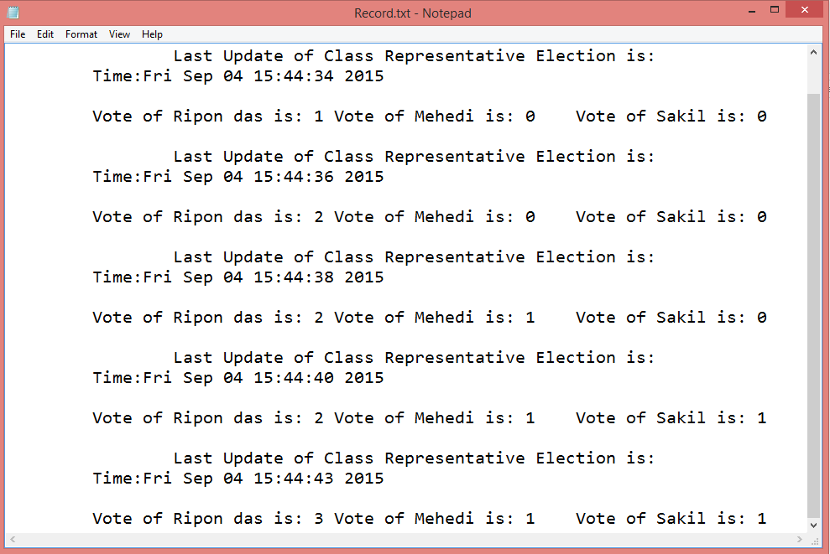

**Chapter 7: Page-48**

**Conclusion:**

My project is an important project for presentation. My project is so dynamic. Almost I have done some features of my project. The project can be used for any presentation doing some modification on it.

URL: https://archive.org/details/ripon_cse_voting_system

**Reference:**

* Programming in ANSI C by E.Balagurusamy
* The Complete Reference by Herbert Schildt